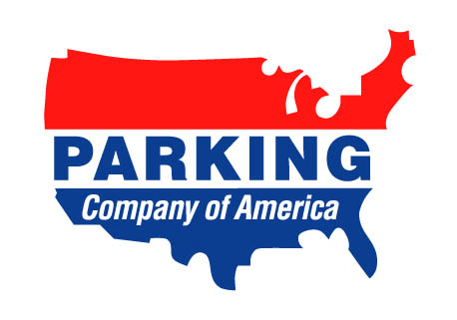
Parking Company of America, Inc.
250 W. Court Street, Suite 200E
Cincinnati, OH 45202
Phone: 513-241-0415
Fax: 513-241-0497
email: bedmonds@pca-star.com
To: Carmen Jones, Payroll Dept.
From: Brenda Edmonds
CC: Toni Kennett & Donna Silvernell
Re: Payroll deduction L. B. Davis, New Orleans, LA
Carmen,
Do to an incident on August 12, 2004 New Orleans lot #14, the attendant, L.B. Davis was negligent for not following procedures and locking a customer’s keys in the vehicle,. Effective this pay period ending 09/12/04 please deduct $18.00 from his pay for reimbursement of the Pop A Lock invoice to have the vehicle unlocked.
If you have any questions let me know.

